Blender notes

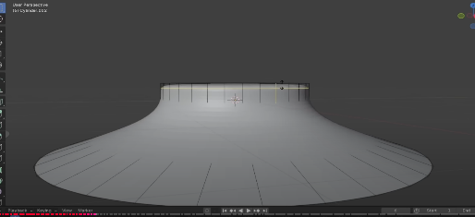1-To add circular(ring ) select all edges and then bridge edges + modifier mai generate+ subdivision(soft and smooth)

2- to add thickness modifier mai generate +solidify

Conrol+r Edge Loop-----------------------------------------------------------

3- make sperate object from same object press p and selection

4- ctrl+I = use for selecting those faces which we don’t selected

by us

5- ctrl+j to move all

6- in modifier bevel is used for corner curving

7- Bebeal for egdeLoop ctrl+b

8- edge Loop Ctrol+r

9 – Inverse faces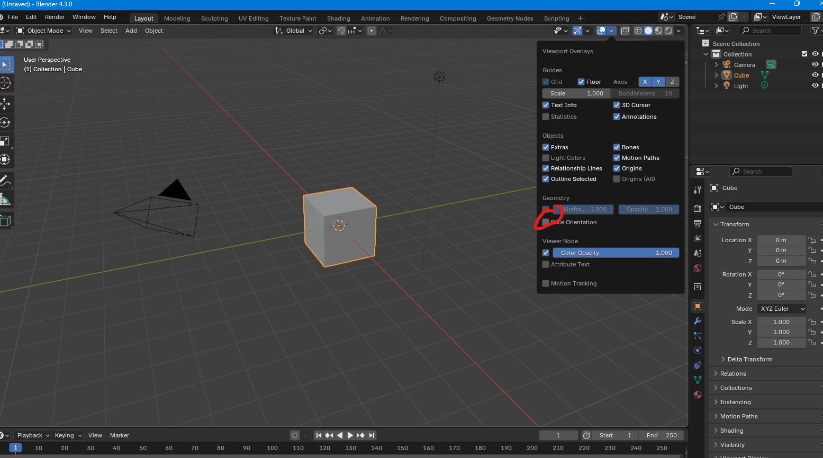

Then alt+n in edit mode then select flip

10- use array to dublicate the object in --modifier